November 19, 2021
Dear Families of the Class of 2026:
We hope this message finds you well! We are looking forward to hosting you at our Virtual Incoming Freshman Enrollment Information Meeting on Thursday, December 2, 2021 6:00-7:00 p.m. Alternate dates Tuesday, December 7, and Tuesday, December 8, 2021.
Registration Form for Information Night
The following information is a summary of important future dates related to course registration, online enrollment, and residency verification:
Future Huskies Night on Tuesday, January 18, 2022, from 6:00-8:00 p.m. @ OPRF (students are encouraged to attend). Prior to this event you will receive additional communication regarding your family counselor assignment and the evening offerings.
Submit all health and dental records by the following deadlines:
- Students planning to participate in athletics during any season should have the Certificate of Child Health Examination form completed after Sunday, May 1, 2022, to ensure athletic eligibility for the entire freshman year.
- Students who will participate in a fall sport must turn in physicals before Monday, August 1, 2022.
- The DHS Certificate of Child Health Examination form WILL BE ACCEPTED for participation in athletics.
- Illinois High School Association (IHSA) forms are not necessary for freshmen.

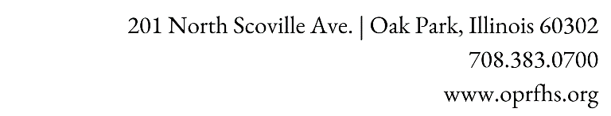
Online enrollment and residency verification in June and July 2022
Further instructions will follow in the spring via email. Please note that course selections will not be valid unless you complete your student’s online enrollment and residency verification.

Please check out these additional resources:
- Incoming Freshman | Students
- OPRF Family Survival Guide
- OPRF Student Handbook 2021-2022 SY
If you have any questions, please do not hesitate to contact our offices. We look forward to supporting your family throughout their time at OPRF.
In partnership,
Faith Cole Dr. Julie Lam
Director of Student Services Director of Student Learning
fcole@oprfhs.org jlam@oprfhs.org
Gabriela Martinez
Enrollment & Registrar Manager
gmartinez@oprfhs.org

